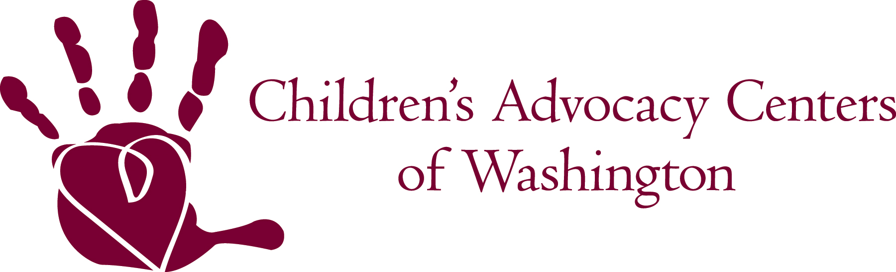

2011 Legislative & Public Policy Agenda

Tier 1 – Legislative and public policy issues that CACWA will take the lead in supporting

Funding for Children’s Advocacy Centers
CACWA will lead efforts to maintain funding for Children’s Advocacy Centers and CACWA at the current rate.

Amending RCW 26.44.30 (12)(a) regarding interviewing children
CACWA will take the lead in amending RCW 26.44.30 to identify Children’s Advocacy Centers as the preferred location for child interviews in cases of child abuse and neglect, including sexual abuse.

Tier II – Legislative and public policy issues that CACWA may support or oppose

Crime Victim Services for Children
CACWA will support funding for crime victims centers, sexual assault centers, and other organizations that provide support and advocacy to child victims of crime.

Crime Victim Compensation Program Benefits and Funding
CACWA will support adequate funding for the Crime Victims Compensation program, and the services provided to child victims through the CVC program and oppose any efforts to reduce funding to this program.

Protection of the Rights of Child Victims
CACWA will support efforts to maintain or strengthen the rights of child crime victims including those related to forensic interviewing, medical evaluations, therapy, advocacy, privacy rights, input, and notification.

Statute of Limitation
CACWA will support efforts to expand the statute of limitation for crimes against children.

Tier III – Issues CACWA will monitor

- Proposals related to sex offender sentencing, treatment, restitution, or registration.
- Proposals related to strengthening laws or programs that protect children from abuse or neglect.
- Proposals that strengthen the ability of our partner agencies to respond to victims of child abuse and neglect.
- Proposals that address mandated reporting of child abuse and neglect.

